

**Department of CSE**

**CSE209 Lab**

**Course Name: Electrical Circuits**

**Course Code: CSE209**

**Section No: 2**

**Experiment No: 07**

**Name of the Experiment:** DC Circuit Analysis in PSpice using Source and Resistance Sweep.

**Date of submission: 12/09/21**

Student’s Name: Md Abdul Ahad Rifat

Student’s ID: 2020-1-60-215

**Submitted to**

Rashedul Amin Tuhin

Senior Lecturer

Department of Computer Science and Engineering

East West University

**Objectives:**

1. To analyze DC circuit in PSpice by sweeping source and resistance.

2. To verify maximum power transfer theorem.

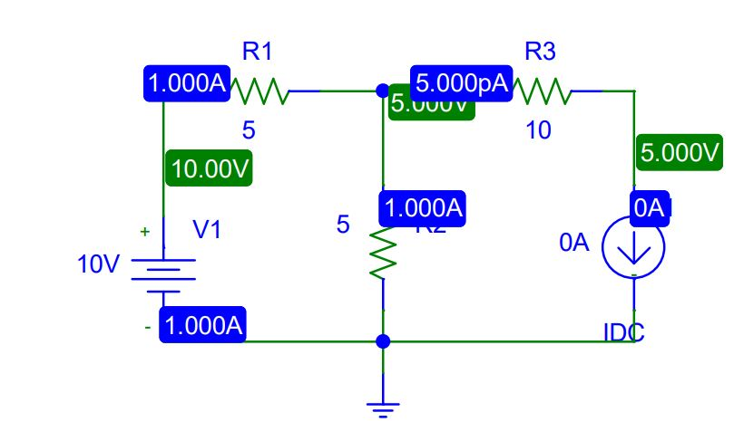**Circuit Diagram(s):**

**Figure 1.PSpice Schematic diagram for circuit 1**

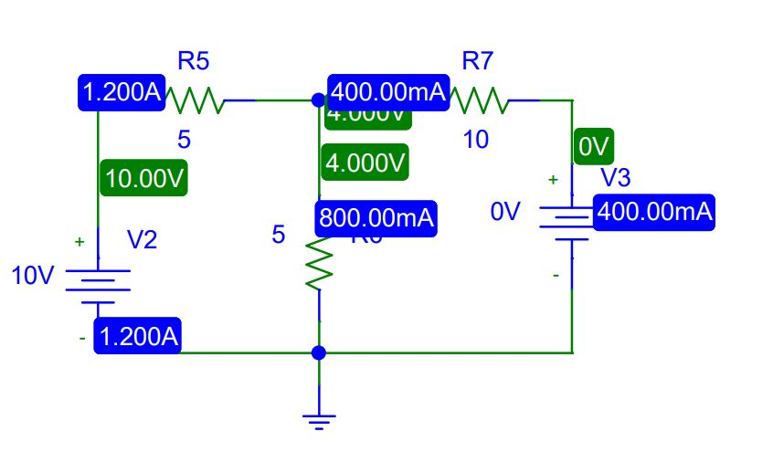

**Figure 2.PSpice Schematic diagram for circuit 2**

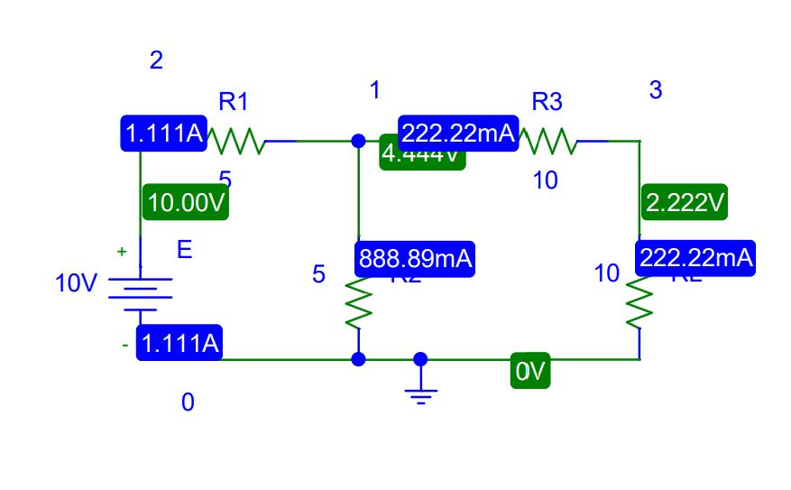

**Figure 3.PSpice Schematic diagram for circuit 3**

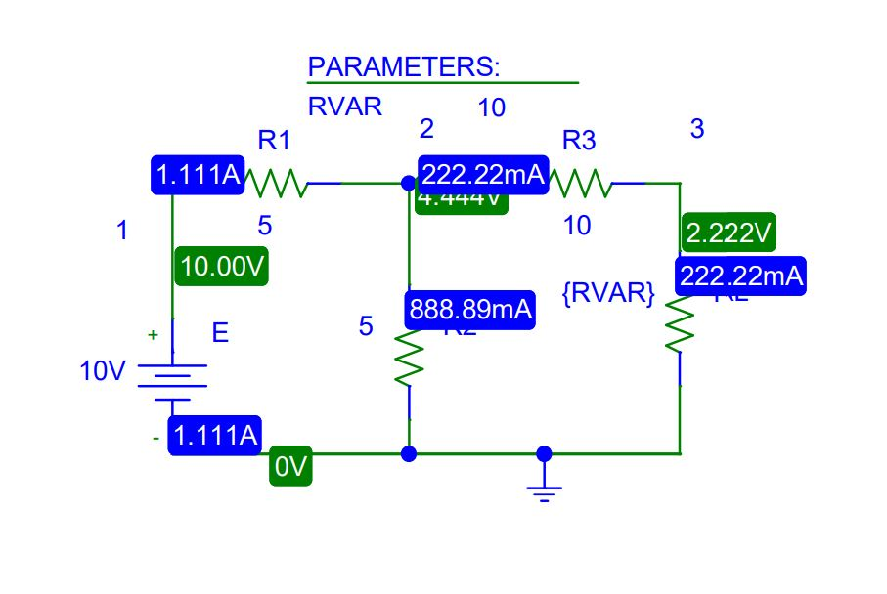

**Figure 4.PSpice Schematic diagram for circuit 4**

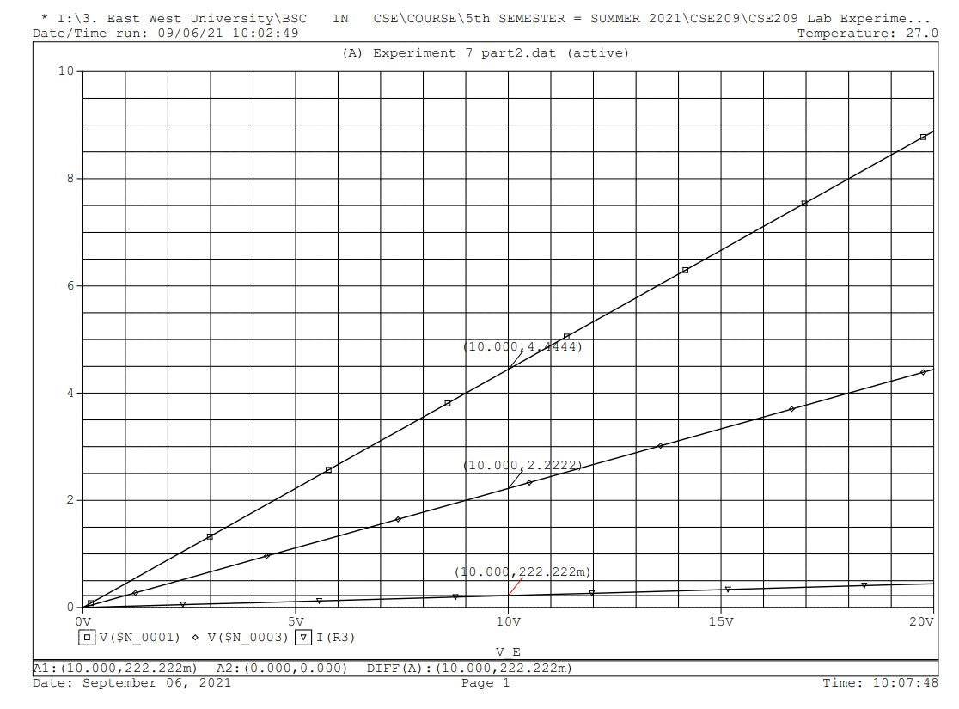**Graph:**

**Figure 5.Voltage and Current characteristic graph using DC Sweep**

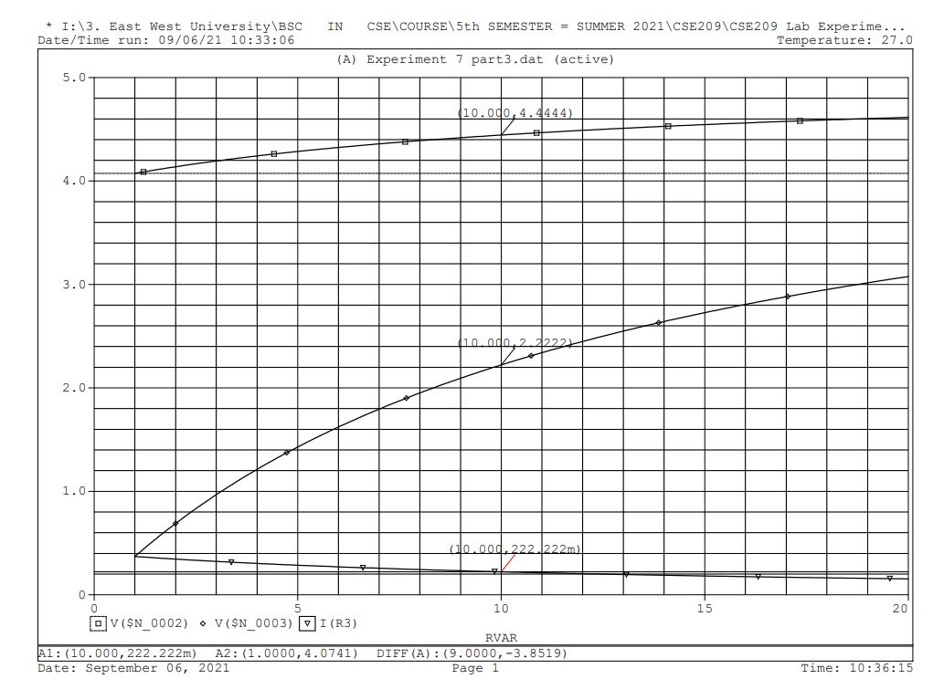

**Figure 6. Voltage and Current characteristic graph using Resistance Sweep**

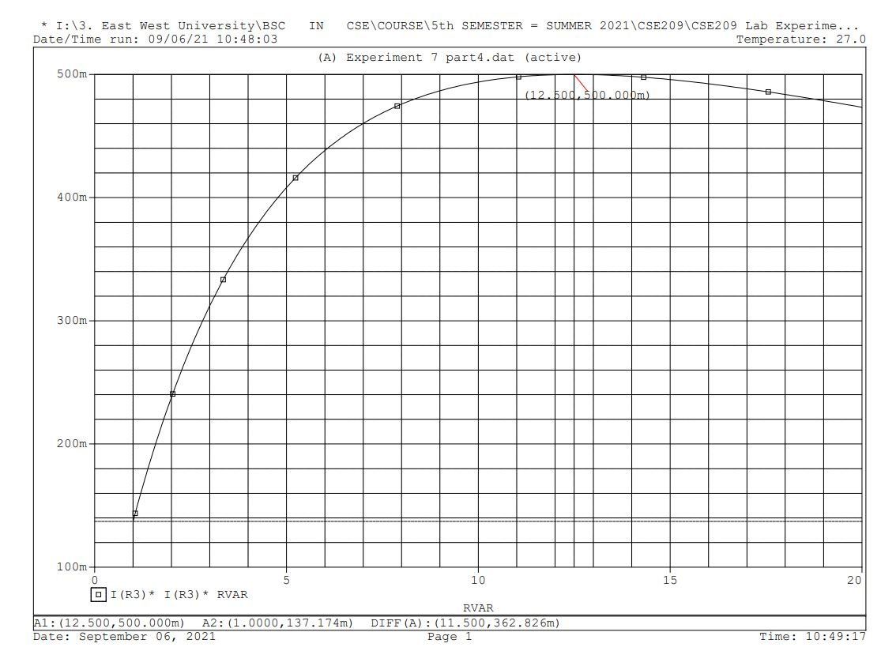

**Figure 7.Graph 3 for the maximum power transfer**

**Post-Lab Report Questions and Answers:**

1. Compare the values of V (1), V (2) and I (R3) obtained in steps 4 and 5(d).

**Answer:**

There has been no change between the values of V (1), V (2) and I (R3) obtained in steps 4 and 5(d). Both of the steps the value are the same .If we see figure 5 and 6 the graph shows us V (1), V (2) and I (R3) value are the same.

V (1) = 4.4444V

V (2) = 2.2222V

I (R3) = 222.22mA

1. Compare the load resistance RL for maximum power transfer obtained in steps 3 and 5(e).

**Answer:**

We know, $R_{th}=R_{L}$ if the power is maximum

In the steps 3,

**In figure 1,**

$$E_{th}=V_{OC}=5.000V$$

**In figure 2,**

$$I_{SC}=400mA$$

**So**, $R_{th}=\frac{V_{OC}}{I_{SC}}$

$= \frac{5v}{400mA}$

$R_{th}$ $= 12.5Ω$

In the steps 5(e),

We see in the figure 7 the power is maximum when $R_{L}=12.5Ω$

1. Compare the theoretical solutions with the solutions obtained from PSpice and comment on any observed discrepancy.

**Answer:**

**Theoretical Calculation:**

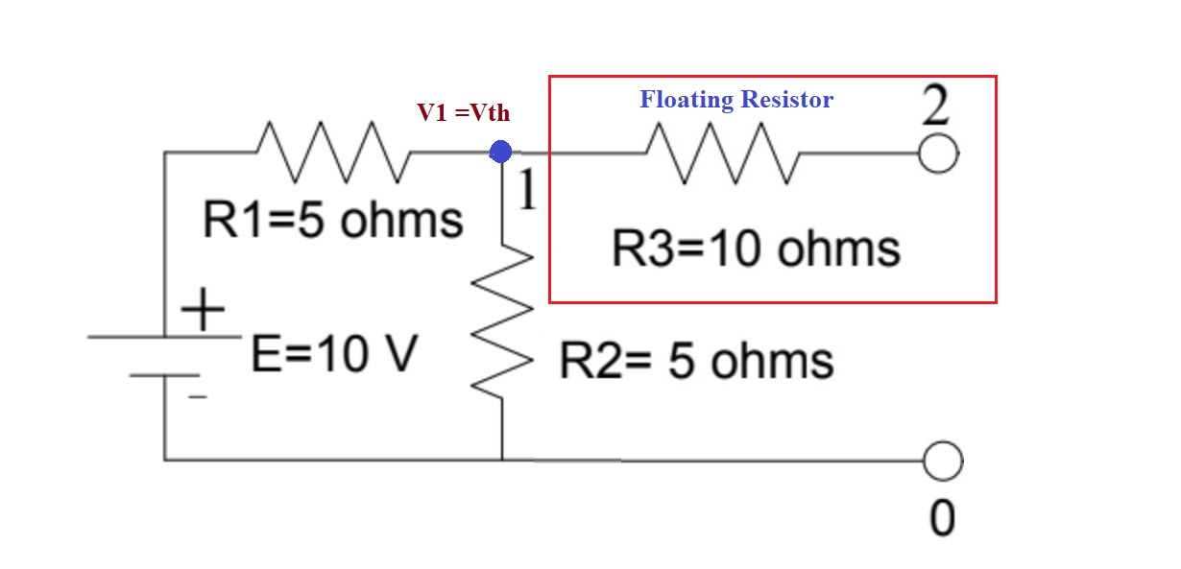

**Figure 8.Calculation for Vth**

Using VDR,

$$V_{th}=\frac{5×10}{5+5}$$

$$V_{th}=50V$$

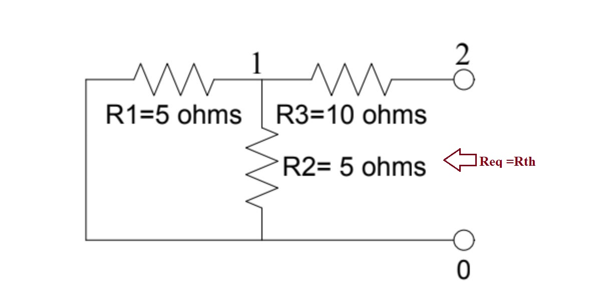

**Figure 9. Calculation for Rth**

$$R_{th}=\left[5||5\right]Ω+10Ω$$

$$R_{th}=2.5Ω+10Ω=12.5Ω$$

$$P_{max}=\frac{5^{2}}{4×12.5} watt=0.5watt= 500mwatt$$

**Table 1.Comparing Theoretical Value and PSpice Simulation Software Value**

|  |  |  |
| --- | --- | --- |
| Name | Theoretical Value | PSpice Simulation Value |
| RL | 12.5Ω | 12.5Ω |
| Pmax | 500mWatt | 500mWatt |

There has been no discrepancy between theoretical value and PSpice simulation

**Conclusion:**

In experiment 7 we analysis DC circuit in PSpice using Source and Resistance Sweep. Also we use Thevenin's theorem to measure Rth and maximum power transfer into this circuit. In this experiment we use one new element which is the parameter to measure load resistance. Now we know how to measure maximum power in a circuit.